Database & Collection
use companyDB
db.employees.insertMany([
{
emp_id: 101,
name: "Amit",
department: "IT",
skills: ["Python", "MongoDB", "Docker"],
projects: [
{ name: "HRMS", duration: 6, technologies: ["Python", "MongoDB"] },
{ name: "Ecommerce", duration: 8, technologies: ["NodeJS", "MongoDB"] }
],
salaries: [45000, 48000, 52000],
certifications: ["AWS", "Azure"]
},
{
emp_id: 102,
name: "Neha",
department: "HR",
skills: ["Communication", "Recruitment"],
projects: [
{ name: "HiringPortal", duration: 4, technologies: ["PHP", "MySQL"] }
],
salaries: [35000, 38000],
certifications: ["SHRM"]
},
{
emp_id: 103,
name: "Ravi",
department: "Finance",
skills: ["Excel", "Tally", "SQL"],
projects: [
{ name: "Accounting", duration: 10, technologies: ["SQL", "PowerBI"] }
],
salaries: [40000, 42000, 46000],
certifications: ["CPA", "CFA"]
},
{
emp_id: 104,
name: "Pooja",
department: "IT",
skills: ["Java", "Spring", "MongoDB"],
projects: [
{ name: "BankingApp", duration: 12, technologies: ["Java", "MongoDB"] },
{ name: "CRM", duration: 7, technologies: ["Spring", "MySQL"] }
],
salaries: [50000, 54000, 60000],
certifications: ["Oracle", "AWS"]
}
])

- Display all employees who have MongoDB skill

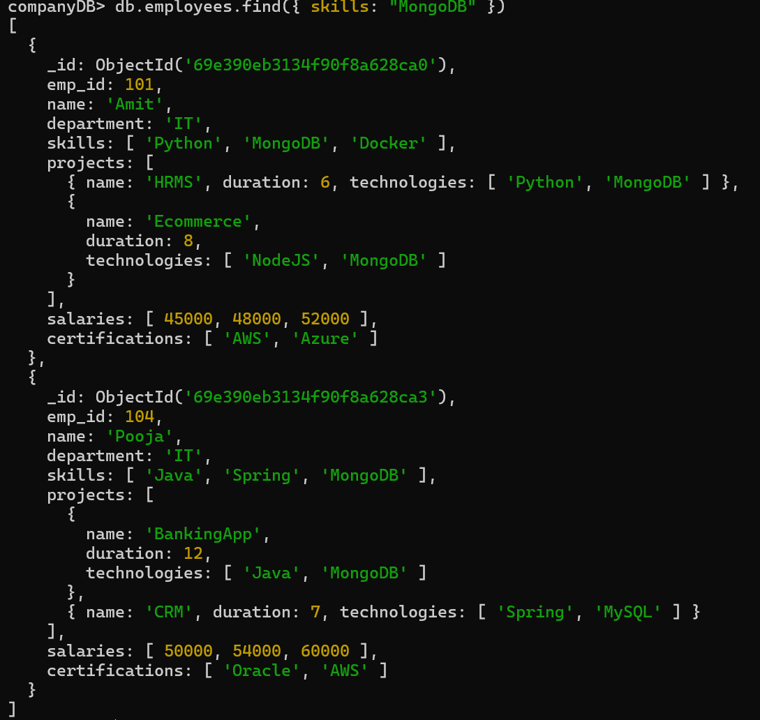

- Find employees having both Python and MongoDB skills
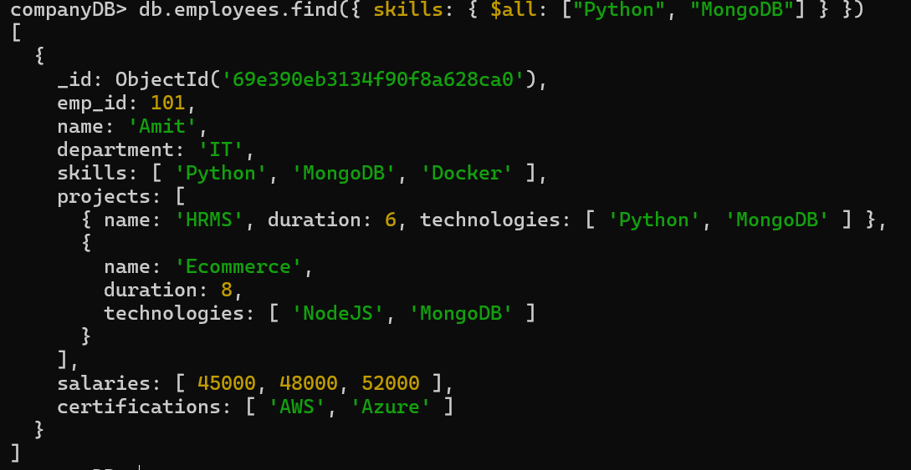

3. Display employees with more than 2 skills
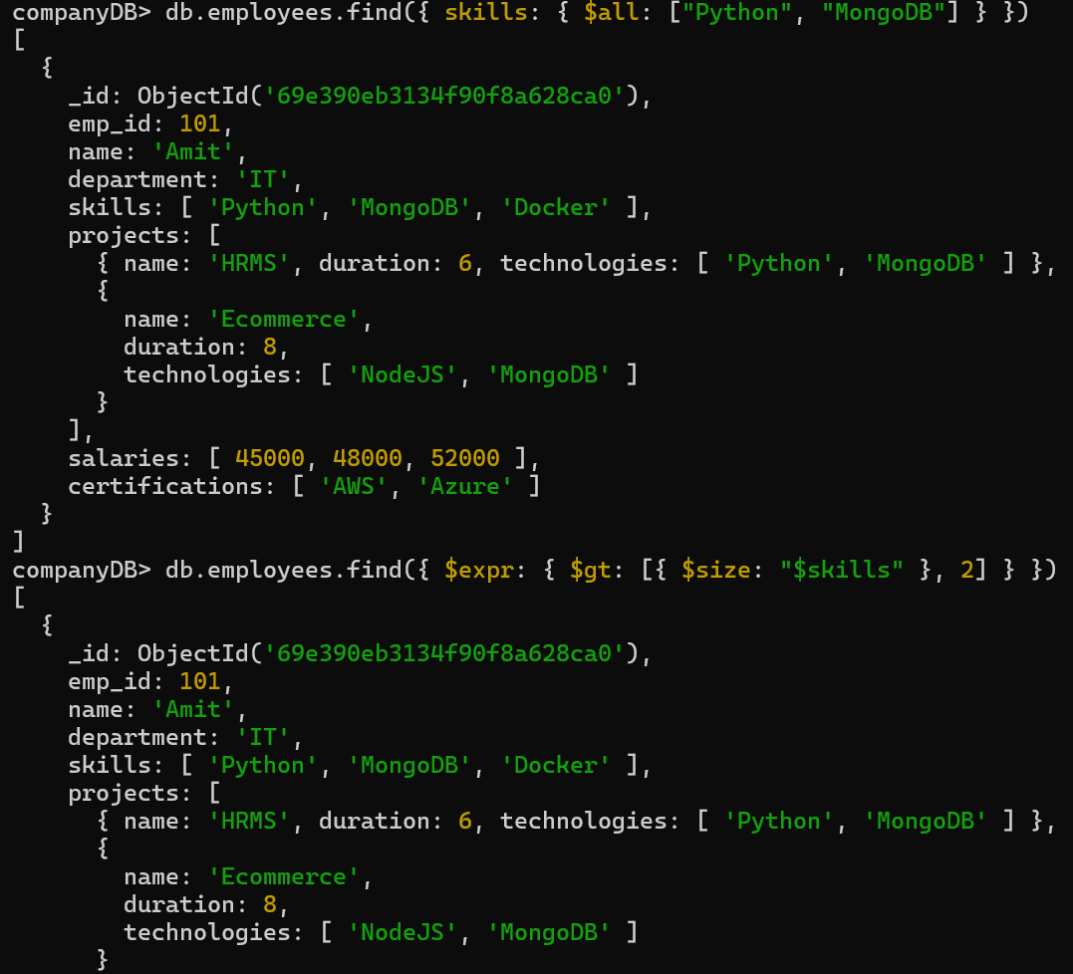
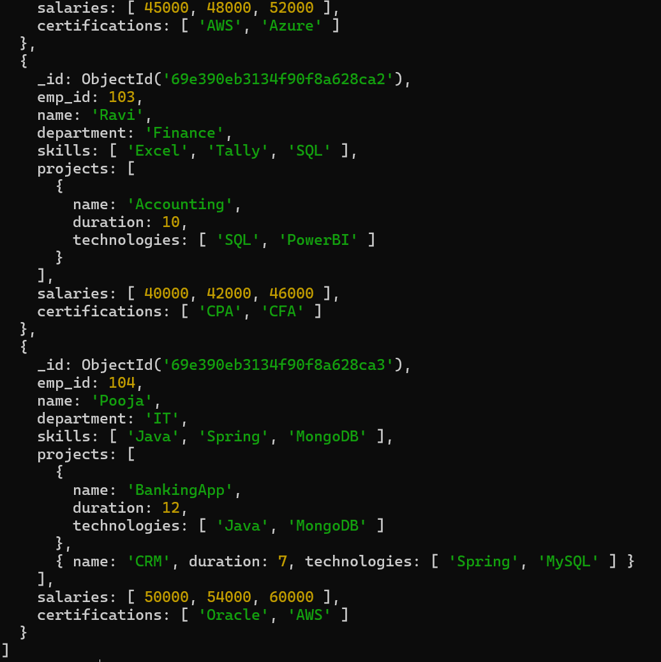
5. Add multiple skills to Pooja
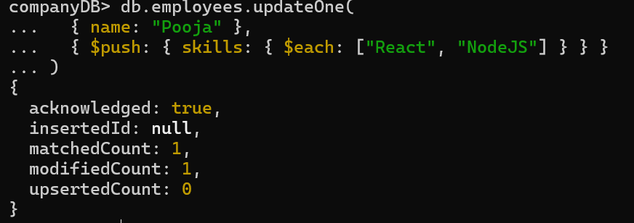

6. Add a certification only if not already present

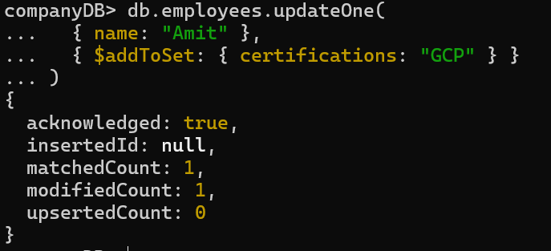
7. Remove "Docker" skill from Amit
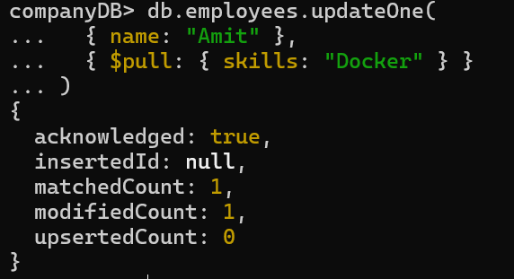
8. Remove multiple salaries less than 45000
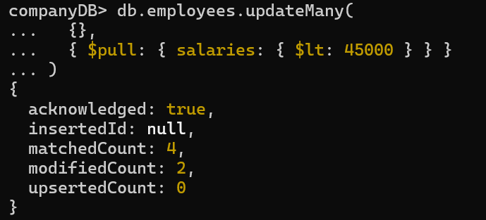

9. Find employees who worked on MongoDB projects
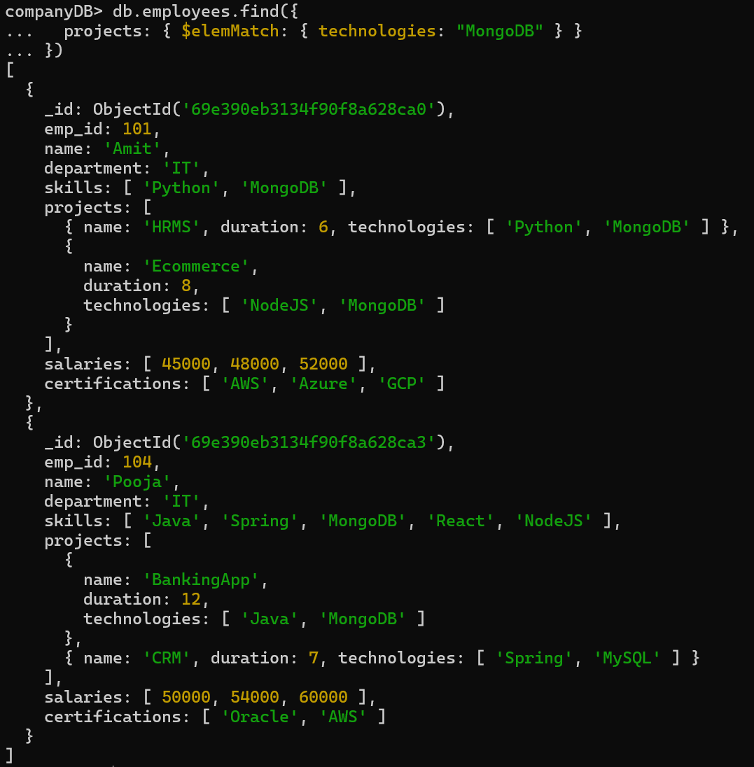

10. Use $elemMatch to find project duration > 6 using MongoDB
--- TOPIC NOT COVERED

11. Count number of projects for each employee
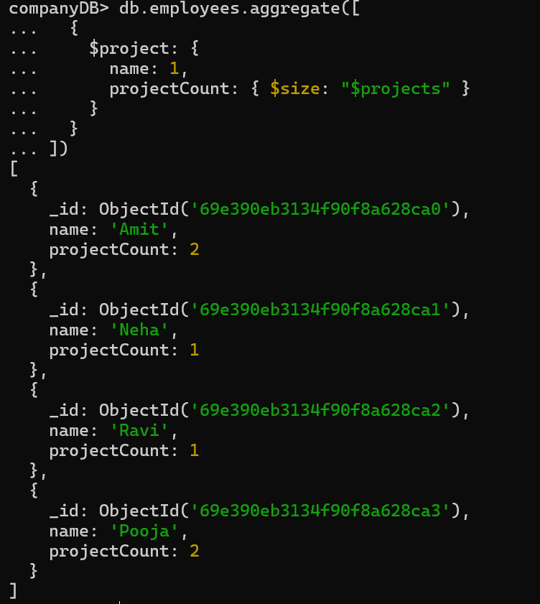
12. Unwind skills array
--- TOPIC NOT COVERED
13. List unique skills across companY
--- TOPIC NOT COVERED

14. Find employees with salary greater than 50000
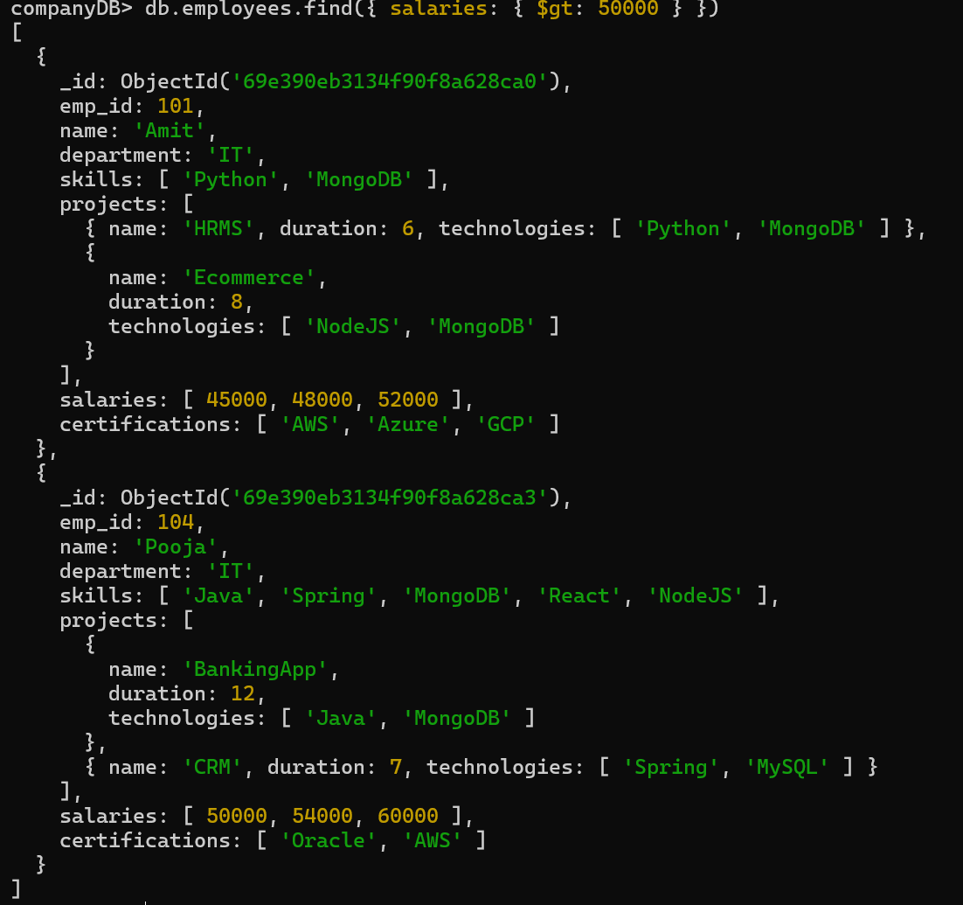

15. Find employees with salary greater than 50000
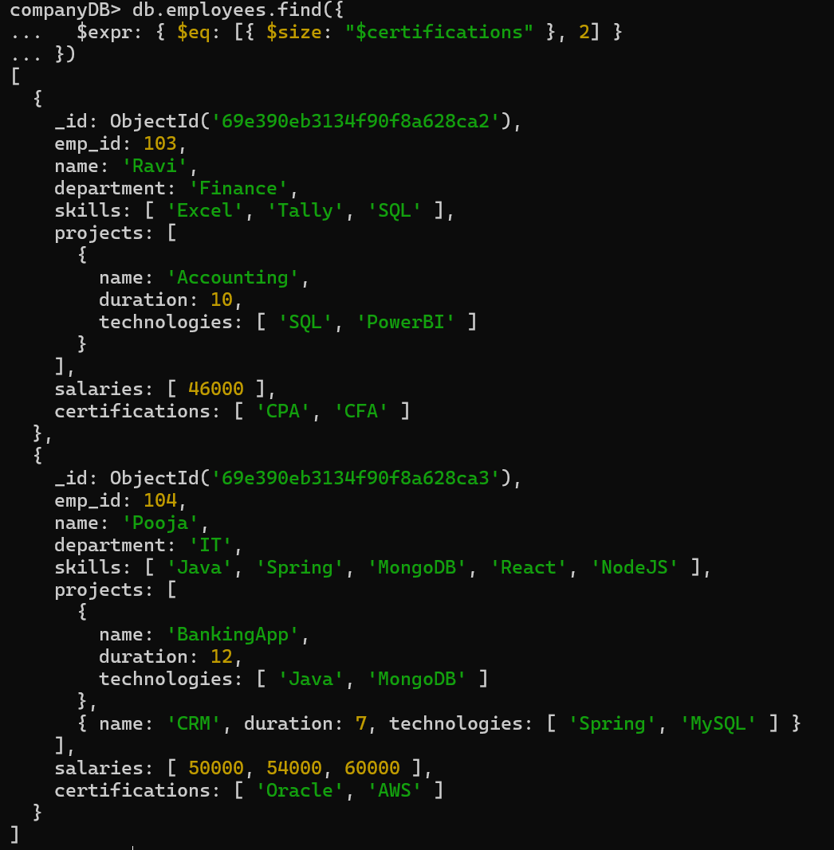
16. Add new project to Ravi
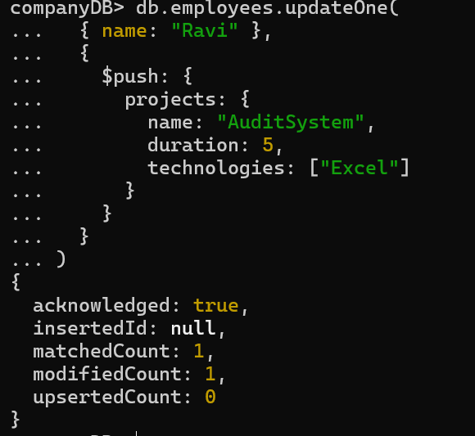

17. Increase all salaries by 10% (array update)
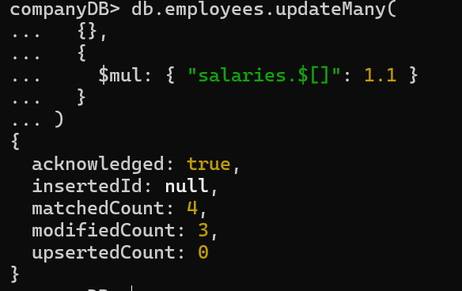
18. Find highest salary of each employee
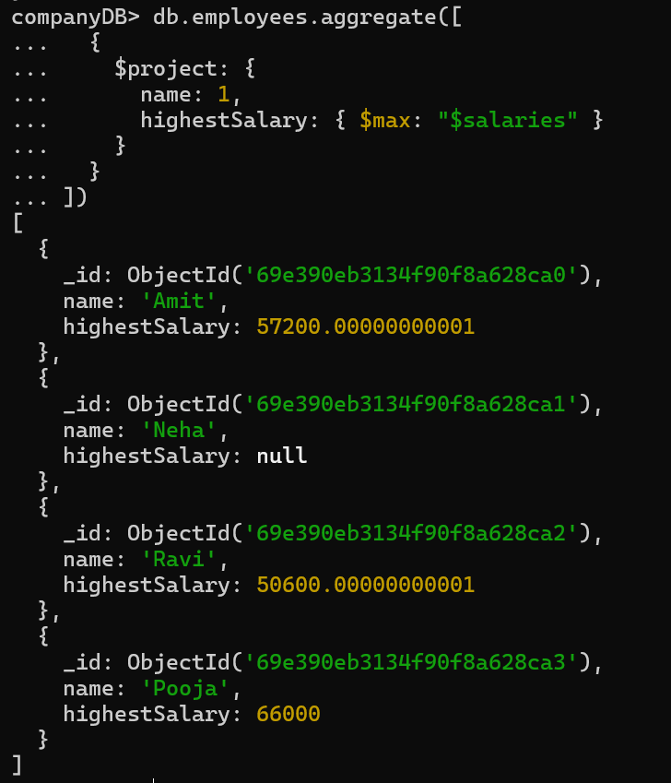

19. Find average salary of employees
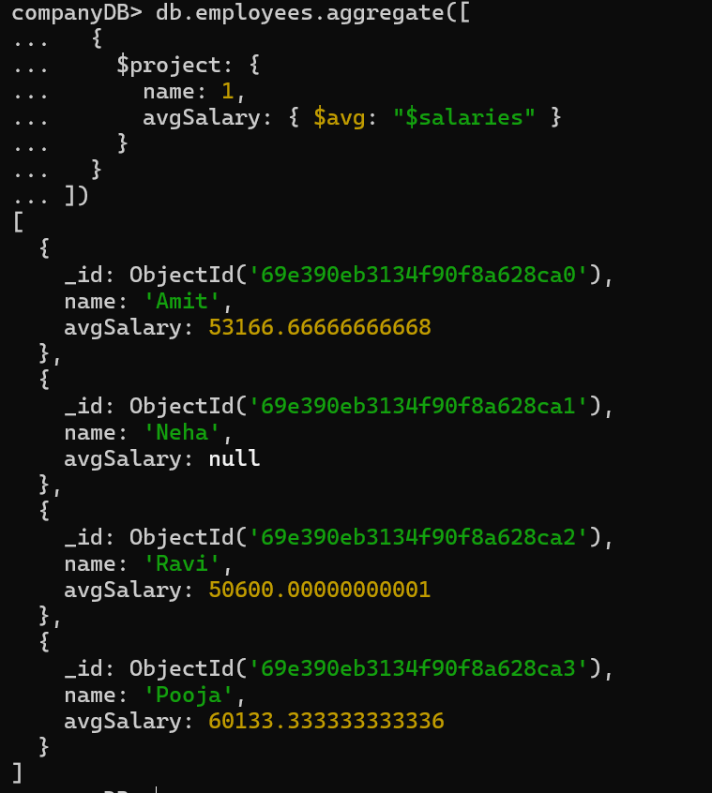

20. Filter projects longer than 6 months
--- TOPC NOT COVERED

21. Find employees who have any of these skills: Java or Python
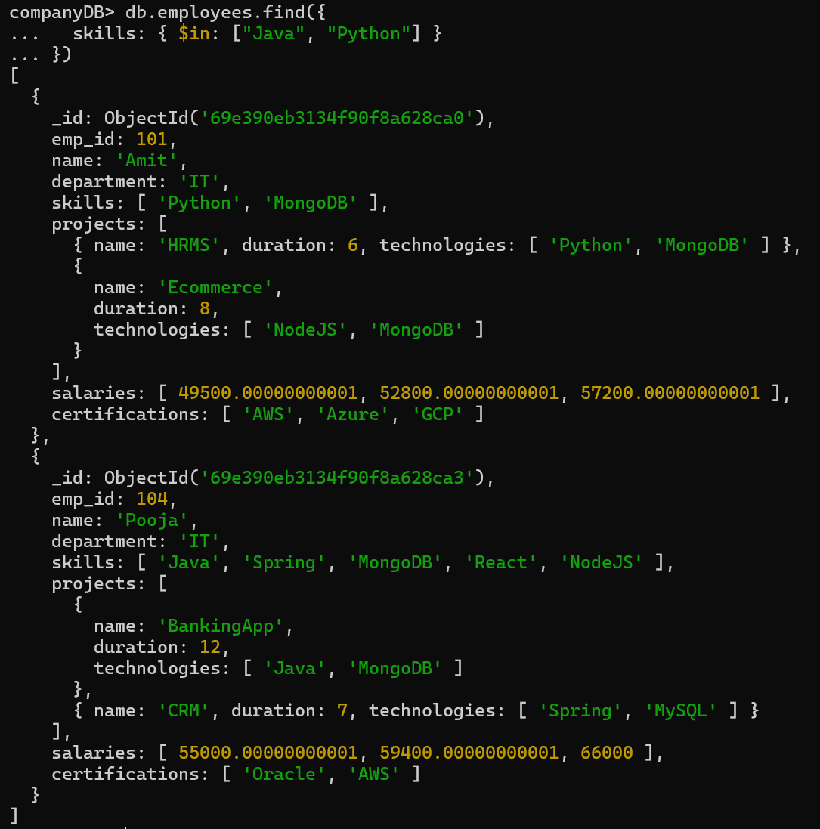

22. Remove last salary entry
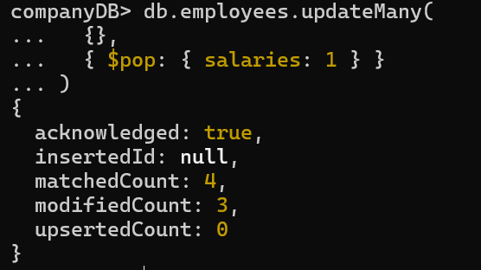
23. Remove first salary entry
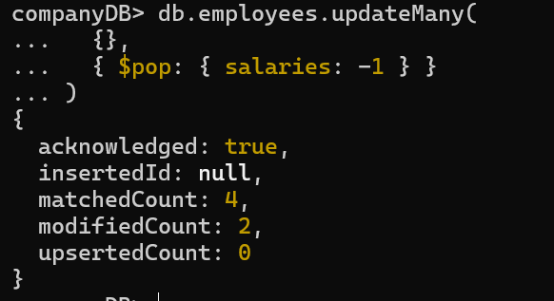

24. Sort salaries array
--- TOPIC NOT COVERED

25. Limit salaries array to last 2 entries
--- TOPIC NOT COVERED
26. Find total salary paid to each employee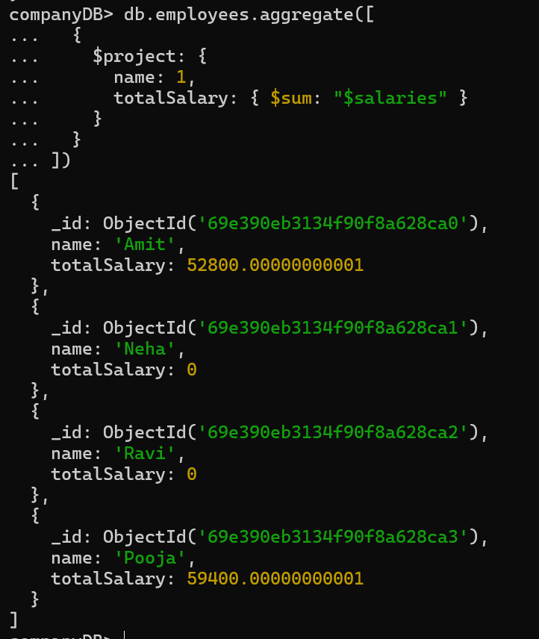

27. Convert skills to uppercase
---- TOPICS NOT COVERED
28. Find employees with more than one project
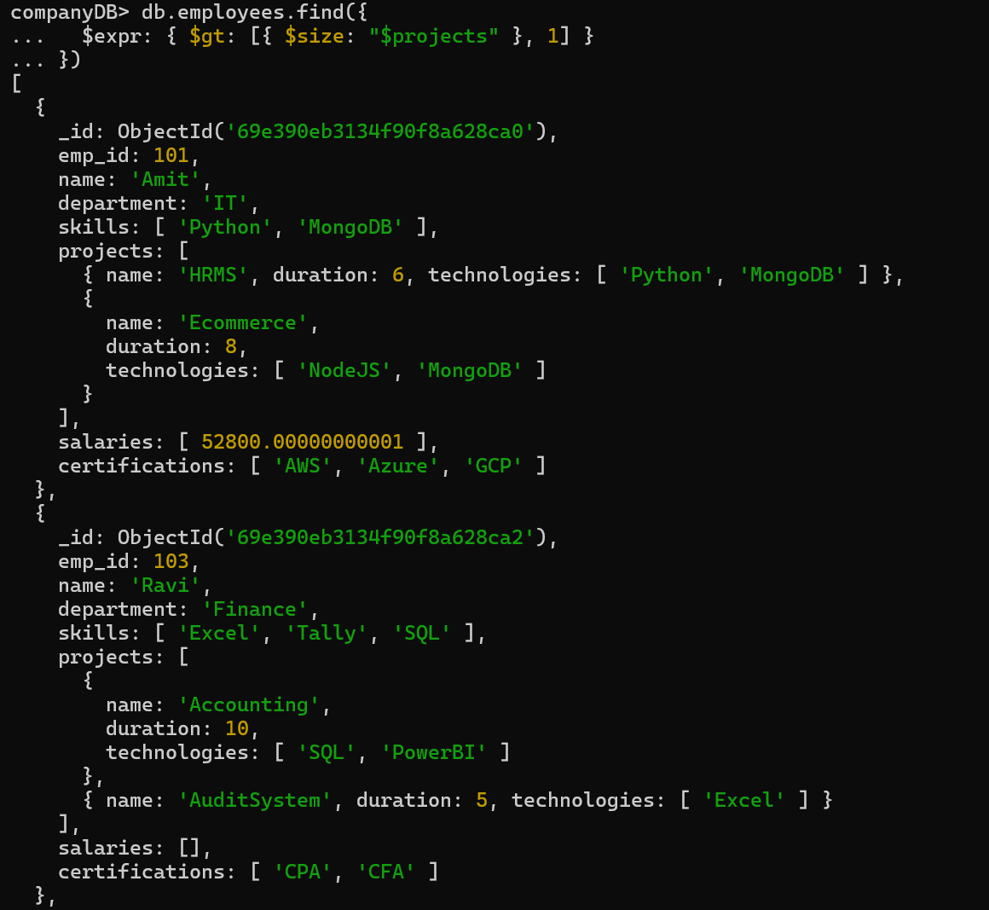
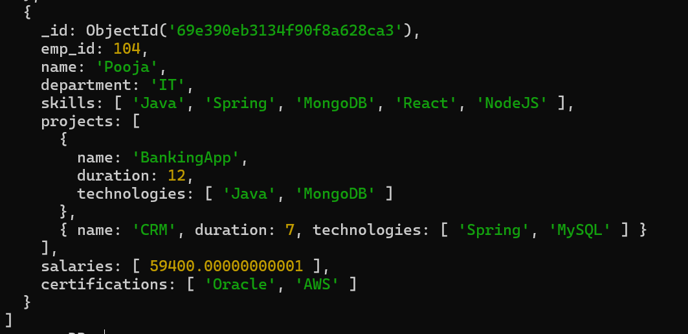

29. Count employees per skill
---- TOPICS NOT COVERED
30. Find employees whose all projects use MongoDB
---- TOPICS NOT COVERED

